(Lakeside Article for Publication in Askern Gazette November 2013)

Flu Campaign October 2013
Thank you to all patients and staff for making this year's flu campaign go smoothly.
Tell us what you thought! Was there anything we could have done better, what went well and what did you like about it? Was it well organised and were staff helpful and attentive?
Also a big thank you to the Nursing Team who wore their fundraising fancy dress for the two Saturday morning sessions. If you donated to the funds then we thank you!! We’re currently up to just over £2,000!
If you'd like to get in touch you can either email us on the Lakeside Practice Email or call in and fill in a Comments & Suggestion Form handing it in to the Reception.
Your comments are welcomed and may be acted upon if it is a valid suggestion.
Email: lakesidepractice@gp-c86016.nhs.uk
Thank you!
Also please note: Christmas & New Year Opening Times
Check out our opening times over Christmas and the New Year period.
Monday 23rd Dec 8am - 6pm
Tuesday 24th Dec8am - 6pm
Wednesday 25th Dec Closed
Thursday 26th Dec Closed
Friday 27th Dec 8am - 6pm
Saturday 28th & Sunday 29th Closed as normal
Monday 30th Dec 8am - 6pm
Tuesday 31st Dec 8am - 6pm
Wednesday 1st Jan Closed
Thursday 2nd Jan 8am - 6pm
Friday 3rd Jan 8am - 6pm

They’re also available on our website and on the Facebook page as a reminder. Click on our 'Opening Times' tab at the top of our webpage to have a look.
Happy Christmas Shopping!!

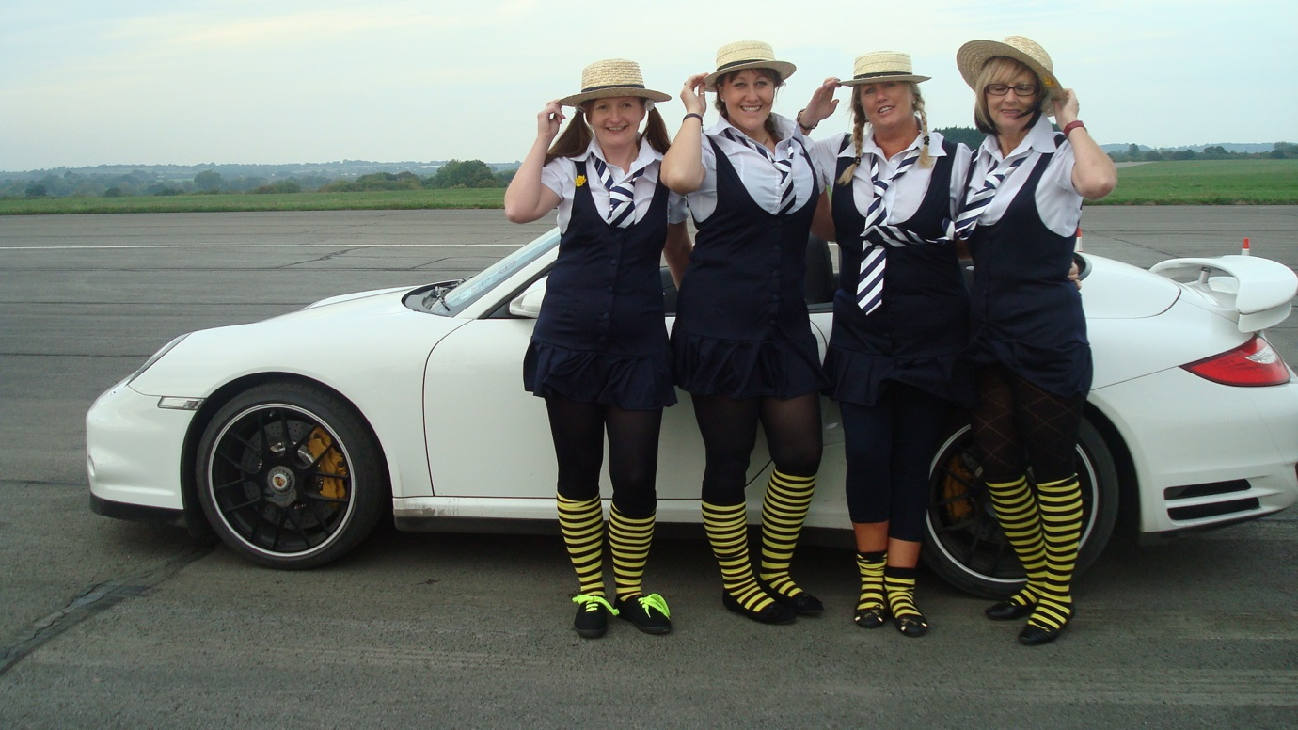
Elaine Dixon, Pat Hargreaves, Helen Lee & Jo Phipps-Bennett fund raising in their fancy dress. September 2013.

